**QUERIES AND SCREENSHOTS**

1. **Total Number of Distinct Flights**

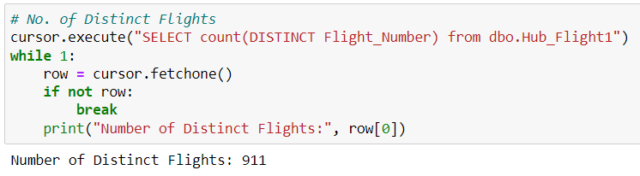

1. **Flights Going to USA Country**

query = "SELECT COUNT(sf1.[Hub Flight Hash Key]) from dbo.Sat_Flight1 sf1 inner join dbo.Link_Flight_Airport1 lfa on sf1.[Hub Flight Hash Key] = lfa.[Hub Flight Hash Key] inner join dbo.SAT_AIRPORT sa on sa.[Hub Airport Hash Key] = lfa.[Hub Airport Hash Key] inner join dbo.Hub_Airport ha on ha.[Hub Airport Hash Key] = sa.[Hub Airport Hash Key] where sa.Country = 'USA'and ha.IATA_Code = sf1.Destination_Airport"

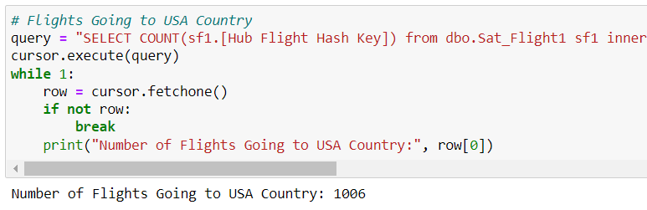

1. **Flights Going to Alaska State**

query = "SELECT COUNT(sf1.[Hub Flight Hash Key]) from dbo.Sat_Flight1 sf1 inner join dbo.Link_Flight_Airport1 lfa on sf1.[Hub Flight Hash Key] = lfa.[Hub Flight Hash Key] inner join dbo.SAT_AIRPORT sa on sa.[Hub Airport Hash Key] = lfa.[Hub Airport Hash Key] inner join dbo.Hub_Airport ha on ha.[Hub Airport Hash Key] = sa.[Hub Airport Hash Key] where sa.State = 'AK'and ha.IATA_Code = sf1.Destination_Airport"

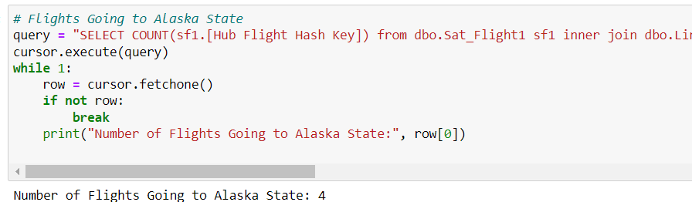

1. **Flights Going to Denver City**

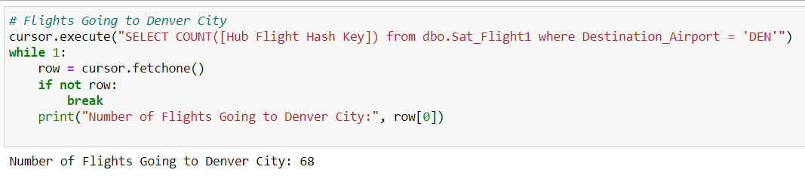

1. **International and Regional Airports**

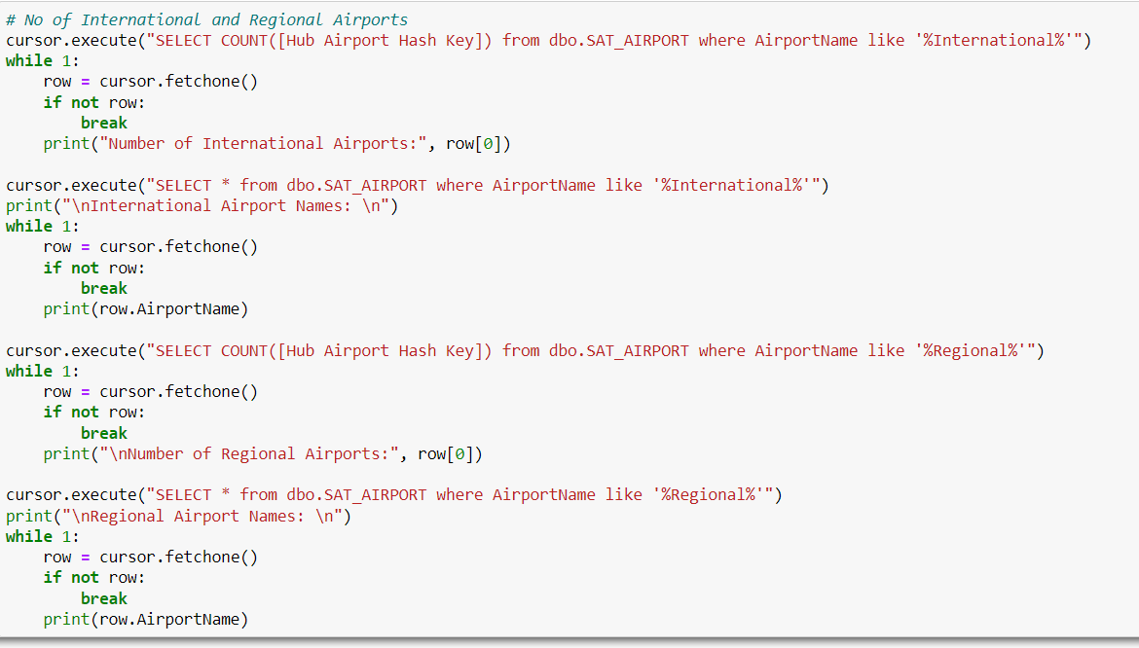

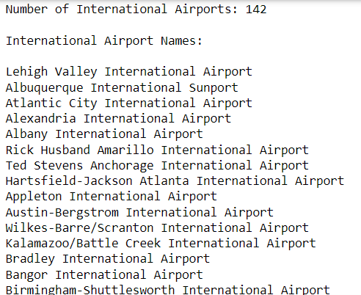

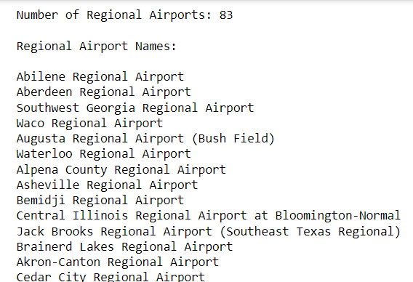

1. **Flights Going to Every State**

query = "SELECT sa.State, COUNT(*) as 'NumberofRunningFlights' from dbo.Sat_Flight1 sf1 inner join dbo.Link_Flight_Airport1 lfa on sf1.[Hub Flight Hash Key] = lfa.[Hub Flight Hash Key] inner join dbo.SAT_AIRPORT sa on sa.[Hub Airport Hash Key] = lfa.[Hub Airport Hash Key] inner join dbo.Hub_Airport ha on ha.[Hub Airport Hash Key] = sa.[Hub Airport Hash Key] inner join dbo.Hub_Flight1 hf1 on hf1.[Hub Flight Hash Key] = sf1.[Hub Flight Hash Key] where ha.IATA_Code = sf1.Destination_Airport Group by sa.State"

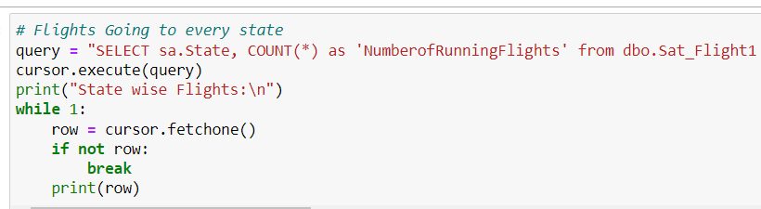

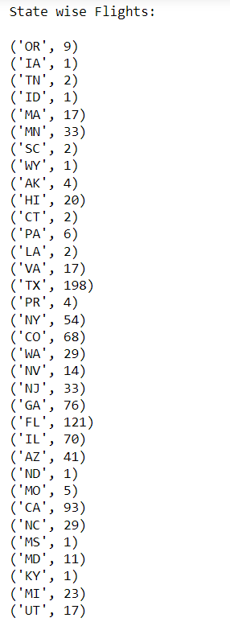

1. **Distinct Airlines**

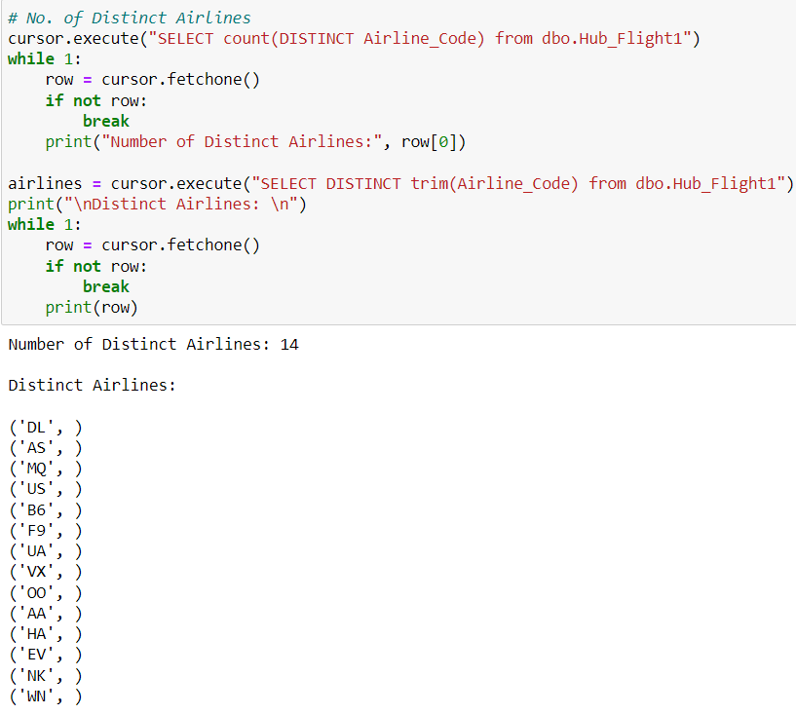

1. **Airline Code Wise Flights**

query = "SELECT trim(hf1.Airline_Code), COUNT(*) as NumberofRunningFlights from dbo.Sat_Flight1 sf1 inner join dbo.Link_Flight_Airport1 lfa on sf1.[Hub Flight Hash Key] = lfa.[Hub Flight Hash Key] inner join dbo.SAT_AIRPORT sa on sa.[Hub Airport Hash Key] = lfa.[Hub Airport Hash Key] inner join dbo.Hub_Airport ha on ha.[Hub Airport Hash Key] = sa.[Hub Airport Hash Key] inner join dbo.Hub_Flight1 hf1 on hf1.[Hub Flight Hash Key] = sf1.[Hub Flight Hash Key] where ha.IATA_Code = sf1.Destination_Airport Group by hf1.Airline_Code order by NumberofRunningFlights desc"

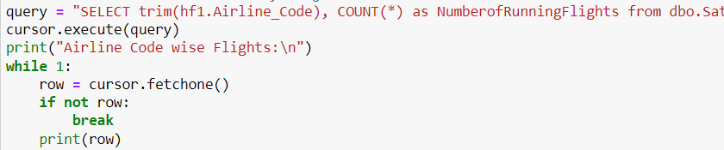

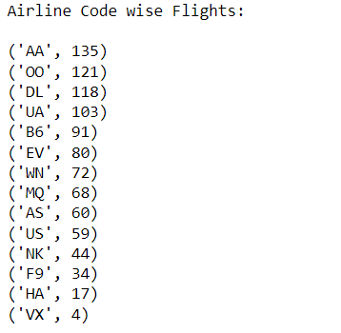

1. **Airline with Maximum Flights**

query = "SELECT top 1 trim(hf1.Airline_Code), COUNT(*) as NumberofRunningFlights from dbo.Sat_Flight1 sf1 inner join dbo.Link_Flight_Airport1 lfa on sf1.[Hub Flight Hash Key] = lfa.[Hub Flight Hash Key] inner join dbo.SAT_AIRPORT sa on sa.[Hub Airport Hash Key] = lfa.[Hub Airport Hash Key] inner join dbo.Hub_Airport ha on ha.[Hub Airport Hash Key] = sa.[Hub Airport Hash Key] inner join dbo.Hub_Flight1 hf1 on hf1.[Hub Flight Hash Key] = sf1.[Hub Flight Hash Key] where ha.IATA_Code = sf1.Destination_Airport Group by hf1.Airline_Code order by NumberofRunningFlights desc"

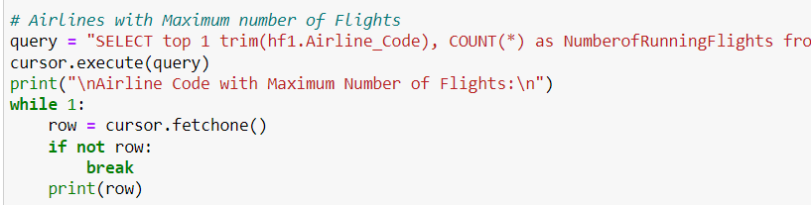

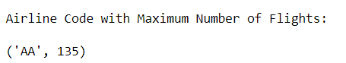

1. **Number of Airports in Arizona, Delaware and New York States**

